Memory Management in OS || Contiguous Memory Allocation

Multiprogramming -> many processes - > RAM

OS should process processes independently in isolated environment.

In Multi-programming environment, we have multiple processes in the main memory (Ready Queue) to keep the CPU utilization high and to make computer responsive to the users.

To realize this increase in performance, however, we must keep several processes in the memory; that is, we must share the main memory. As a result, we must manage main memory for all the different processes.

Every process is executing independently

For every process OS will set base separately in ram. And also set offset

Offset is starting point in main memory

Logical address starts from 0. Physical address is computed using offset (addressing range of current process) and base (starting point in physical address).

Os throws error securing the isolation, if the addres computed is out of range or holds other process.

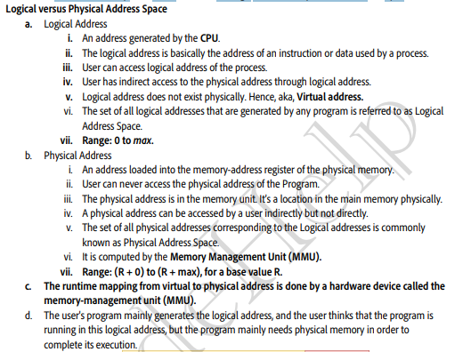

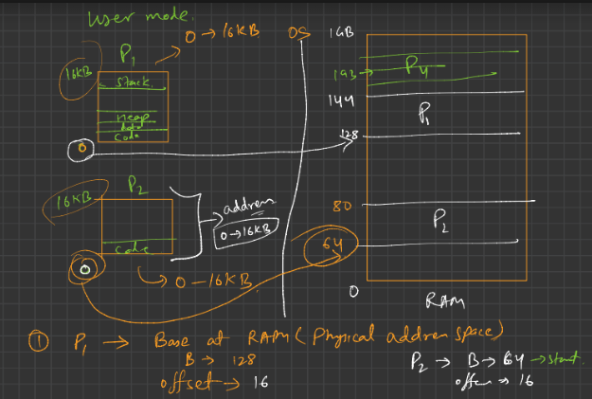

How OS manages Virtual Address Space?

1. OS provides this Virtual Address Space (VAS) concept
2. To separate memory space, we need the ability to determine the range of legal addresses that the process may access and to ensure that the process can access only these legal addresses
3. The relocation register contains value of smallest physical address (Base address [R ]); the limit register contains the range of logical addresses (e.g., relocation = 100040 & limit = 74600).
4. 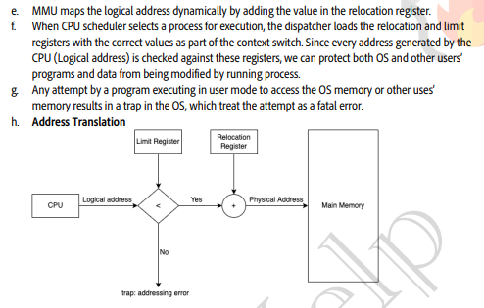

Types of physical memory allocation:

1. Contiguous Allocation: Allocating memory continuously
   1. In this scheme, each process is contained in a single contiguous block of memory.
   2. Types of partitioninig of memory
   3. Fixed Partitioninig - Partitions are made of same size
      1. Eg. All the partitioninig of 4mb
      2. 3mb processes places in the partitions. This wastes 1 MB per partition
      3. This is causing External partition
      4. If we had new process, this may not able to fit as memory is limited to, but if external was not there, new process would have been fitted
      5. 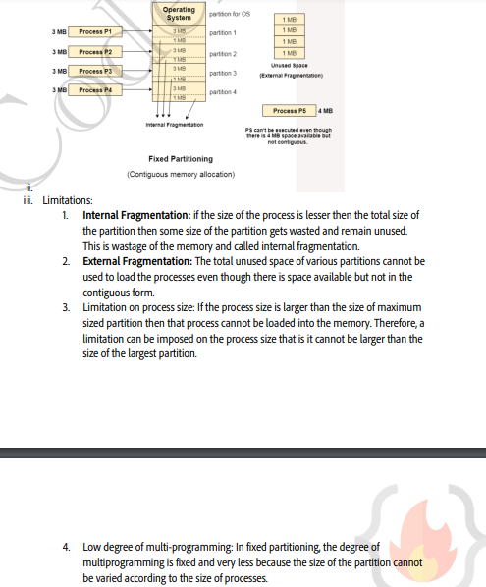
   4. Dynamic Partitioning:
      1. 